Use cases to acceptance tests

CSE2102 Introduction to Software Engineering

Instructor: Therese Smith

Jianxing Ke

01/31/2015

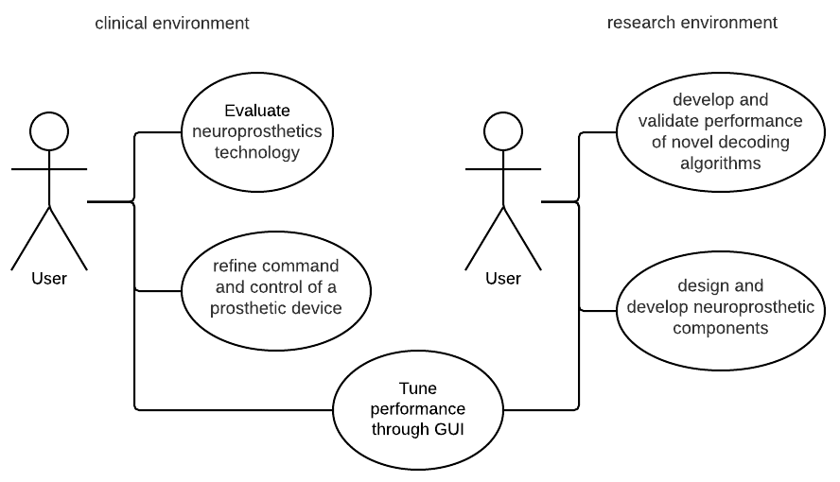

Use case for my project

